AUSTRALIAN 18 FOOTERS LEAGUE SAILING INSTRUCTIONS
2018-2019 SEASON TO COMPLY WITH WORLD SAILING FEDERATION RACING RULES OF SAILING 2017-2020

The Organizing Authority (OA) is the Australian 18 Footers League

1 RULES

1.1 The rules, as defined in the Racing Rules of Sailing 2017-2020 (“RRS”) of the
World Sailing Federation.

1.2 The Marine Safety (General) Regulation 2009.

1.3 The rules and regulations applicable for the 18ft Skiff Class, all as modified by these Sailing Instructions and Australian 18 Footers League’s Sailing By-Laws. (‘Addendum E’)

2 NOTICES TO COMPETITORS

Notices to competitors will be posted on the official notice board located alongside
the office door in the Australian 18 Footers League, 77 Bay Street, Double Bay.

3 CHANGES TO SAILING INSTRUCTIONS

Any changes to the Sailing Instructions will be posted not less than two (2) hours
prior to the start of the race it will affect, except that any change to the ‘Schedule
of Races’ will be posted by 2000 on the day before it will take effect.

4 SIGNALS MADE ASHORE

4.1 Signals made ashore will be displayed on the flag mast of the Double Bay Sailing
Club

4.2 When flag AP is displayed ashore, ‘one (1) minute’ is replaced with ‘not less than
thirty (30) minutes’, in the race signal AP

5 SCHEDULE OF RACES

5.1 The schedule of races to be sailed is described in ‘Addendum A’

6 CLASS FLAGS

The class flag will be a white rectangular flag displaying the Australian 18 Footer
League logo

7 RACING AREA

The location of the racing area is shown on ‘Addendum B’

8 COURSES

8.1 The courses are listed on ‘Addendum C’

8.2 No later than the warning signal, the Race Committee start boat will display the
Course number to be sailed as described in ‘Addendum C’

A competitor sailing the incorrect course will be subject to protest by the Race Committee.

3-Buoy races will use similar course numbers, as listed in ‘Addendum C’, but
Three (3) windward marks as described in SI 9.3 will be positioned at the windward end of the course.

Each entrant will be issued with a clear instruction as to which mark they must
round each lap.

9 MARKS

9.1 The Start/Finish mark will be a white and black checkered inflatable bearing the
Australian 18 Footers league logo.

9.2 All inflatable rounding marks as described in ‘Addendum C’ will be inflatable
orange cylinders with white band and fluro ends and may bear an Australian 18 Footers
League logo or sponsors logo.

9.3 For races where three windward marks are laid (for handicapping purposes) these
marks will be clearly labeled with letters and/or a variety of colours(red/white/blue)

9.4 All YA rounding marks described in ‘Addendum C’ will be Yachting NSW yellow spherical, cylindrical or spar shaped buoys and can be replaced with a different mark without warning. Amends RRS 34

9.5 The inadvertent touching of a mark (but not attaching to or shifting a mark) is
permitted. In the event that a mark is engaged causing it to shift or becomes
attached to a skiff, RRS Rule 31 in its entirety will apply. This amends RRS Rule 31.

10 THE START

10.1 Race signals will be made in accordance with RRS 26 .

10.2 The starting line will be between the flag mast of the Race Committee vessel bearing
the Class Flag and the designated start mark, which will be on the Committee
Vessel’s port side

Sound Signals:
Attention will be drawn to the Warning, Preparatory, One Minute and Starting
Signals by a sound signal.

11 RECALLS

11.1 Individual Recalls shall be made in accordance with RRS Rule 29.1.
Each skiff will be allocated a recall number for the season. The Race Committee
may display the recall number of an offending skiff and lower the number when
the skiff has returned to the pre start side of the line or its extensions.

11.2 General Recalls shall be made in accordance with RRS Rule 29.2.

11.3 After a general recall, RRS Rule 30.3 or 30.4 may apply to all subsequent starts.

12 THE FINISH

The finishing line will be between the flag mast of the Race Committee vessel bearing
the Class Flag and the designated finish mark, which will be on the Race Committee
vessel’s port side.

13 PENALTY SYSTEM

A one (1) turn penalty, including one tack and one gybe, applies for a breaching of a
rule of RRS Part 2 Amends RRS 44.1 and 44.2

14 TIME LIMIT

There will be a time limit of three (3) hours, with the exception that if one boat
finishes within the three (3) hour time limit then a time limit extension of one
(1) hour after the finishing time of the first boat is available to all other boats in
which to finish, or the original time limit, whichever is later. If the race cannot be completed within the time limit the race may be abandoned, re-sailed or shortened.
Amends RRS 35.,A4 and A5.

On Multi-Race days the Race Committee may start the second race of the day within 5 minutes of the finishing time of the first race winner.

(Multi-Race Time Limit continued)
The time limit for multi-races will be one (1) hour except boats not finished within
twenty (20) minutes of the first boat may be scored Did Not Finish without a hearing. This amends RRS35.A4 and A5.

The Race Committee can allocate, after the first boat has finished and before the time limit has expired, a finish position to boats that are still on the course and boats so finished will be scored as finished.
This amends RRS28 and amends the definition of “finish”.

15 PROTESTS

Protest forms are available at the race office and shall be lodged in writing with
the race office.

The protest time limit shall be no later than two (2) hours after the last boat has
finished the last race of the day. The same limit applies to protests by the Race
Committee about incidents they observe in the racing area and to requests for
redress. Amends RRS Rules 61.3 and 62.2.

16 SCORING

The scoring is described in ‘Addendum D’.

17 REPLACEMENT OF CREW OR EQUIPMENT

17.1 Substitution of competitors will not be allowed unless approved by the Race
Committee. Requests for substitution shall be made in writing to the Race Committee
a minimum of one hour prior to the scheduled race start time .

17.2 Substitution of damaged or lost equipment will not be allowed unless approved
by the Race Committee. Requests for substitution shall be made in writing to the
Race Committee one hour prior to the scheduled race start time through the race office.

18 EQUIPMENT AND MEASUREMENT CHECKS

18.1 Skiffs competing in races conducted or supported by the Australian 18 Footers
League must have satisfied the Club Measurer, and may be inspected at any time
for compliance with the class rules and sailing instructions.

18.2 All new skiffs must be measured and weighed within two races after their launching.

18.3 The Sail Registration Date (SRD) and cut off for all skiffs to have their sails
measured and signed for use during the 2018-2019 Season is 28 October 2018.
(Only signed sails may be used for competition from 28 October
until the completion of the 2018-2019 Season).

19 RIGGING IN THE PARK

19.1 Skiffs shall be removed from trailers immediately upon arrival in the park.
Trailers shall then be pushed to the western end of the park beyond the most
western concrete path leading to the water. Skiffs failing to comply with this
instruction will be scored DNC on the day of the breach.

19.2 Skiffs failing to comply with the “conditions for use of rigging area, Steyne Park, Double Bay” as issued by the Council of the Municipality of Woollahra will be
scored DNC on the day of breach or on the next race day.

20 SIGN ON REGISTER

The skipper and crew of each competitor shall complete and sign the ‘Sign On Register’,
located at the office of the Australian 18 Footers League, 77 Bay Street,
Double Bay, at least one (1) hour prior to the start of the race. Skiffs that fail to comply with this instruction will be scored DNC on the day of the breach.

21 DISCLAIMER OF LIABILITY

All those taking part in any race conducted by or supported by the Australian 18 Footers League Limited do so at their own risk and responsibility.

The Australian 18 Footers League Ltd is not responsible for the seaworthiness
of a boat whose entry is accepted or the sufficiency or adequacy of its equipment.

Attention is drawn to RRS Fundamental Rule 4 (2017-2020) DECISION TO RACE, which states: “The responsibility for a boat’s decision to participate in a race or
to continue racing is hers alone”.

22 CLUB IDENTIFICATION

22.1 Each registered skiff of the club shall have the words “Australian 18fts League”
or “Aust 18fts League” displayed on the stern in letters at least 45mm in height.

22.2 Each competing skiff shall carry the emblem of the Australian 18 Footers League
(as provided by the club) on each side of the hull near the stern. Any competitor
failing to comply with this instruction may be scored DNC .

22.3 Each competing skiff shall carry the logo www.18footers.com.au (as provided
by the club) on each side of the mainsail. Any competitor failing to comply with
this instruction will be scored DNC.

23 SAIL SIGNS

23.1 Each boat shall have on each mainsail a distinguishing mark of sufficient size
to be approved by the Race Committee. The colour patch shall be submitted with
the entry and can only be altered with the permission of the Race Committee,
applied for at least one (1) hour before the race start time.

23.2 Any skiff carrying the insignia of any other boat on its hull or any of its sails or
any of its crew clothing may be subject to protest by the Race Committee

23.3 Exemption will only be granted for temporary situations and in extenuating
circumstances and shall be applied for by the competitor at least one (1) hour
before the race start time.

24 LEAVING THE RIGGING AREA

24.1 All competing boats shall be fully rigged and standing in a vertical position by
a time NO LATER THAN forty five (45) minutes prior to the scheduled start time
on the day of the race.

24.2 Each competing boat shall be removed from the rigging area and be in the water
by a time NO EARLIER THAN forty five (45) minutes and NO LATER THAN twenty (20) minutes prior to the scheduled start time on the day of the race.

24.3 Any skiff which does not comply with this instruction may be scored DNC

24.4 Any skiffs which prevent another competing boat(s) from complying with this
instruction will be scored DNC.

25 The Race Committee reserves the right to reject or cancel the entry of any boat RRS 76.1.

26 INSURANCE

Boats shall have adequate current Third Party Property Liability insurance cover
and Third Party Personal Liability insurance cover of not less than $10,000,000 (ten
million) for each separate incident

27 STORM JIB and 2nd RIG REEF
When the Race Officer/Starter indicates with a code flag “T” (red/white/blue), for boats that choose to race, it is compulsory that each skiff use the Club allocated ‘storm jib’
When the Race Officer/Starter indicates with a code flag “R” (red/yellow cross), for boats that choose to race, it is compulsory that each skiff reef the mainsail a minimum of 1500mm.

28 SAFETY

28.1 The following safety gear is required to be carried by each boat;

A personal safety knife on each crew;
A distress flag on each crew;
A safety knife attached for easy release on the port transom
A safety air bottle attached to the starboard transom

28.2 Crew choosing to wear a trapeze harness must;

Ensure the trapeze harness has a quick release system that would allow them to free themselves in the event they were trapped underwater;and
ensure the trapeze harness is the outer most garment.

29 NSW MARITIME REGULATION

NSW Maritime advise the following MUST apply:

“All competitors MUST keep 500m from the bow of any ship and at least 200m from the bow of any ferry and no less than 30m from the sides/stern of any ship or ferry underway”.

30 COMMERCIAL AND DEFENCE SHIPPING

30.1 Skiffs shall not interfere with the commercial or defence shipping of the port.
The attention of skippers is drawn to Roads and Maritime Services regulations regarding right of way vessels entering or leaving port, ferries displaying orange diamonds and vessels
engaged in towing. Roads and Maritime Services regulations specify “priority over sail”-some commercial ferries on Sydney Harbour display an orange diamond shape which grants
priority of way over sailing vessels.
30.2 Skiffs found to have interfered with commercial shipping may be subject to action by the Race Committee in accordance with RRS 60.2
30.3 All skiffs must abide by traffic directions of Roads and Maritime Services Boating Officers. Any skiff directed to stop or alter course by Roads and Maritime Boating Services Officers as a result of an anticipated breach of the above rules/regulations shall do so immediately.
30.4 Any skiff reported by Roads and Maritime Services/Sydney Ferries/Sydney Ports Authority as having contravened these regulations may be disqualified without a hearing. This amends RRS 63.1

SEE DIAGRAM BELOW AND ALSO ‘ADDENDUM F’

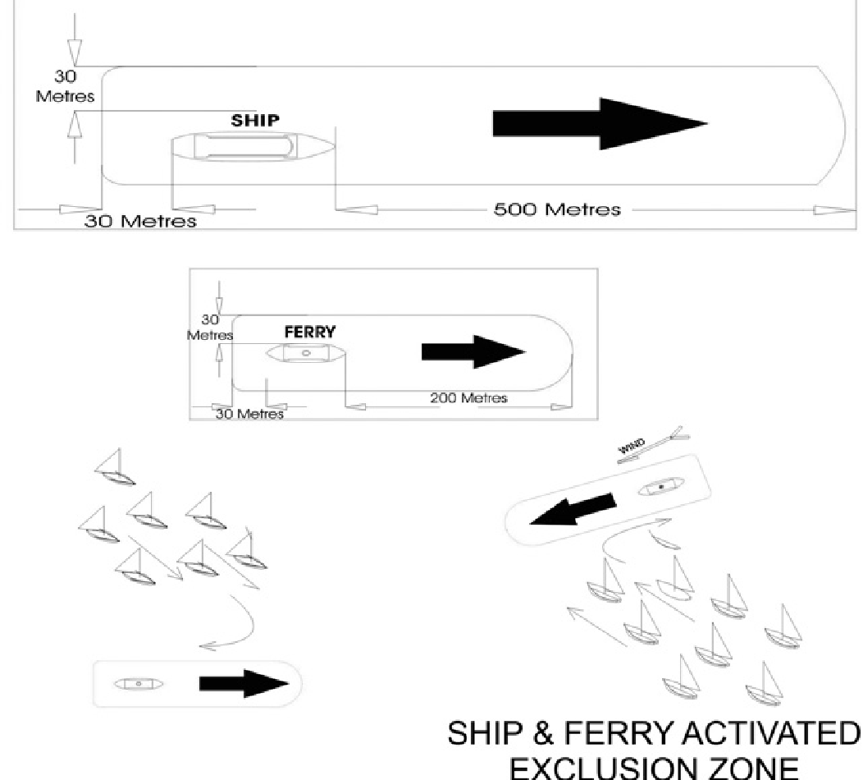

ADDENDUM A

RACE SCHEDULE FOR 2018-2019 SAILING SEASON

October 14 3b Spring Championship - Race 1
Major A. Frizelle Trophy

October 21 3b Spring Championship - Race 2
Alf Beashel Memorial Trophy

October 28 Scratch Spring Champ - Race 3/Club Champ Race 1
Mick Scully Memorial Trophy
Sail Registration Day

November 4 3b Spring Championship-Race 4
Eric Bowen Memorial Trophy

November 11 3b Spring Championship- Race 5&6
Chris Webb Memorial Trophy

November 18 3b Spring Championship - Race 7
Winning Appliances Trophy Ribbon Presentation

November 25 Scratch NSW Championship Race 1/Club Championship race 2
W.C.”Trappy”Duncan Trophy

December 2 Scratch NSW Championship Race 2/Club Championship Race 3
Alice Burton Memorial Trophy

December 9 Scratch NSW Championship Race 3/Club Championship Race 4
Syd Barnett Jr Memorial Trophy
December 14 Scratch SuperCup evening 2 races
December 16 NSW Championship Race 4/Club Championship Race 5
R Watt Memorial Trophy
December 23 NO RACE
December 30 NO RACE

January 6 NO RACE

January 13 Scratch NSW Championship - Race 5 Cordukes Clubhouse Trophy Ribbon Presentation
Club Championship Race 6

January 20 Australian Championship - Race 1&2 Sprint Scratch
Club Championship races 7 & 8

January 26 Australia Day Regatta $1000 prize for handicap winner
Lord Mayor’s Trophy Scratch winner

January 27 Australian Championship –Races 3 & 4 Sprint Scratch
Club Championship Races 9 & 10
Ferry Patrons Trophy

February 3 Australian Championship - Race 5 Scratch
Club Championship Race 11 Commodores Cup

February 10 Australian Championship - Races 6 & 7 sprint Scratch
Club Championship Races 12 & 13
President’s Trophy
February 17 Australian Championship-Races 8& 9 Sprint Scratch Ribbon Presentation
Club Championship Races 14 & 15

February 24 Club Championship Final race 16 Ribbon Presentation

March 1 Friday JJ Giltinan Championship Invitation Race

2 Saturday JJ Giltinan Championship - Race 1 George Calligeros Trophy

3 Sunday JJ Giltinan Championship –Race 2 Cliff Monkhouse Memorial Cup

5 Tuesday JJ Giltinan Championship – Race3&4 Alan Cole Memorial Trophy

6 Wednesday JJ Giltinan Championship – Races 5&6 A J Reynolds Trophy

7 Thursday JJ Giltinan Championship –Race7 Bill Miller Memorial Trophy

9 Saturday JJ Giltinan Championship – Race 8 Big Kite Memorial Trophy

10 Sunday JJ Giltinan Championship Race 9 BOB KILLICK MEMORIAL Ribbon Presentation

March 17 3B Queen Of The Harbour Ribbon Presentation

RACING AREA

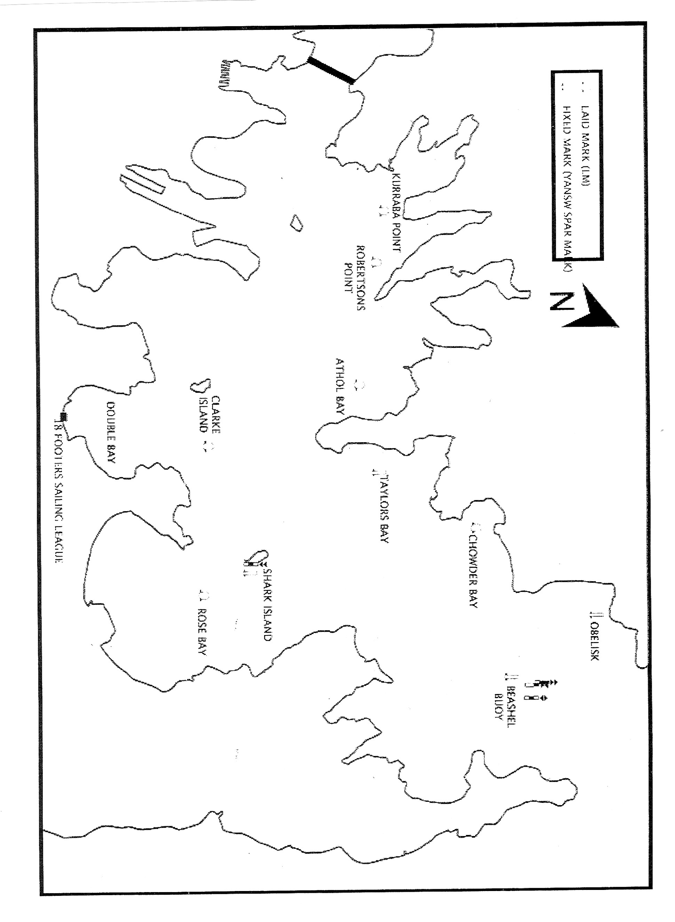

ADDENDUM C
COURSES

COURSE 1 - NORTH-EAST

Start line in vicinity of Clarke Island
Beashel Buoy – YA
Shark Island – YA
Clarke Island – LM
Beashel Buoy – YA
Clarke Island – LM
Beashel Buoy – YA
Shark Island – YA
Finish line in vicinity of Clarke Island

COURSE 2 - EAST

Start line in vicinity of Robertson Point
Rose Bay – LM
Clarke Island – LM
Kurraba Point – LM
Rose Bay – LM
Kurraba Point – LM
Rose Bay – LM
Finish line in vicinity of Clarke Island

COURSE 3 - SOUTH-EAST

Start line in vicinity of Taylors Bay
Rose Bay – LM
Robertson Point – LM (PORT)
Clarke Island – LM (PORT)
Chowder Bay – LM
Rose Bay – LM
Taylors Bay – YA
Rose Bay – LM
Robertson Point – LM (PORT)
Finish line in vicinity of Clarke Island

COURSE 4 - SOUTH

Start line in vicinity of Athol Bay
Clarke Island – LM (PORT)
Obelisk Bay – YA
Shark Island – YA
Athol Bay East – LM (PORT)
Clarke Island – LM (PORT)
Obelisk Bay – YA
Shark Island – YA
Athol Bay East – LM (PORT)
Finish line in vicinity of Clarke Island

COURSE 5 - WEST

Start line in vicinity of Rose Bay
Kurraba Point – LM (PORT)
Clarke Island – LM (PORT)
Rose Bay – LM (PORT)
Kurraba Point – LM (PORT)
Rose Bay – LM (PORT)
Kurraba Point – LM (PORT)
Finish line in vicinity of Clarke Island

COURSE 6/3 - WINDWARD/LEEWARD

Start line
Mark 1 (PORT)
Gate 2
Mark 1 (PORT)
Gate 2
Mark 1 (PORT)
Finish line to port side of Committee Vessel

COURSE 6/4 - WINDWARD/LEEWARD

Start line
Mark 1 (PORT)
Gate 2
Mark 1 (PORT)
Gate 2
Mark 1 (PORT)
Gate 2
Mark 1 (PORT)
Finish line to port side of Committee Vessel

NOTES:
‘YA’ marks are YNSW permanently fixed yellow spar marks.
‘LM’ marks are temporarily laid orange inflatable marks with white band and fluro ends.
In ‘Course 6/3’ and ‘Course 6/4’, Mark 1 will be laid to windward of the start line.
(Distance and bearing will be displayed from the Committee Vessel)
Gate 2 will be laid approximately 0.05 NM to windward of the start line.
If one of the leeward gate marks is missing boats shall round the existing leeward mark to port.
Start locations described for the above courses are a guide only and may vary at the discretion of the Race Committee.

ADDENDUM D

SCORING

The Low Point System as described in RRS 2017-2020, Appendix A, as modified will apply.RRS A9 Race Scores in a series longer than a regatta replaces RRS A 4.2 for all races conducted by the Australian 18 Footers League during the 2018-2019 Racing Season.

Such points will be scored on club conducted events as follows:

Season Point Score
A total of points scored in the handicap section of each race listed on Addendum A of these instructions will count towards the Season Point Score. There will be no discard.

Club Championship
There shall be sixteen (16) races, as listed on Addendum A of these instructions, to count towards the Club Championship. There will be no discard.

NSW Championship
There shall be five (5) races, as listed on Addendum A of these instructions, of which a minimum of three (3) races shall be completed to constitute the series. In order for the worst score to be excluded from a boat’s point score fiver (5) or more races shall be completed.

Australian Championship
There shall be nine (9) races, as listed on Addendum A of these instructions, of which a minimum of four (4) races shall be completed to constitute the series. In order for the worst score to be excluded from a boat’s point score five (5) races shall be completed.

Spring Championship
There shall be eight (7) races, as listed on Addendum A of these instructions, there will be no discard

ADDENDUM ‘E’

SAILING BY LAWS

ENTRIES

No skiff shall be allowed to start in any race unless all required documentation has been completed to the satisfaction of the Race Committee.

The Race Committee has the right absolutely to refuse registration or cancel any existing registration.

HANDICAPS

The Race Committee shall be responsible for allocation and review of all handicaps.

PRIZES

The committee shall be responsible for the determination of the amount and distribution of all prizes.

ALTERATION OF SKIPPER

Should it be necessary to make a change in the skipper of a skiff on the day of the race, the starter shall be notified of such alteration no later than two (2) hours prior to the scheduled starting time. The Race Committee shall be furnished with an explanation in writing (within 24 hours) by the appointed representative of the reason for the change and they shall have the power to call for such evidence as to the necessity for the alteration as they think fit. The skiff’s placing in the race will not be confirmed until the Race Committee is satisfied with the explanation.

SIGNAGE

Each skiff shall carry a design on each side of the mainsail. Such designs must first be approved by the Race Committee, which has the right to refuse or alter a design. No skiff will be allowed to compete in a race unless it meets these requirements.

SUSPENDED PERSON

Any person under disqualification or suspension from Australian 18 Footers League membership shall not be allowed to become a member of any crew competing in a race during the term of their disqualification or suspension.

OFFICIAL REPORT

The starter and timekeeper shall submit reports of all such matters falling within their respective duties to the Race Committee as required.

SKIPPERS & CREWS

All members of each registered skiff taking part in the club’s sailing events must be a financial member of the club and must have been a member for at least seven (7) days prior to the event.

All members of each registered skiff taking part in the club’s sailing events must have a current “Australian Sailing” Membership.

DEAD HEAT

In the case of a dead heat, the prize money and points shall be equally divided. If a cup or other prizes which cannot be divided, the race shall be resailed by the skiffs having made the dead heat, if practicable. If not, the destination of the prize shall be decided by ballot.

ADDENDUM F

REPORTING MARINE ACCIDENTS
AND THE MARINE SAFETY ACT 1998
AND THE MARINE SAFETY (GENERAL) REGULATIONS 2009.

The provisions of the Marine Safety Act 1998 (the Act) came into operation on the 30th March 2009.

The Marine Safety (General) Regulations 2009, (The Regulations) also came into force on the 30th March 2009.

They may be accessed at www.legislation.nsw.gov.au

The Act and Regulations replace the obligation under section 30G of the Maritime Services Act 1935 to report marine accidents involving death or injury or damage exceeding $100.

The Act and Regulations also replace the provisions of a Memorandum of Understanding between NSW Maritime and Yachting NSW which related to collisions between racing vessels.
The MoU was not widely circulated or understood by Clubs.

Under section 99 (1) of the Act a master and owner have an obligation to report a marine accident.

Regulation 96 sets out the conditions where a report is not required, and is therefore required in all other circumstances, and substantially changes the reporting requirements. It has particular relevance to racing yachts competing subject to an Aquatic Licence granted to a Club.

Three separate situations are referred to in Regulation 96 and these are set out in the following Table and state the conditions where a report IS required.

Types of vessels involved Conditions for reporting

Vessels two or more ALL of which are NOT racing.
Fatality or personal injury or Damage exceeds $5000

Vessels two or more of which ALL are racing
Fatality or personal injury or Damage exceeds $5000

Vessels one of which is racing and one of which is not racing
Fatality or personal injury or Damage exceeds $5000

SAILING VESSEL INCIDENT REPORT
(FOR INCIDENTS INVOLVING SAIL VESSELS OPERATING UNDER SAME AQUATIC LICENCE)

Please fax completed form to NSW Maritime on (02)9563 8699
- Was any person injured requiring medical treatment? Yes/No
- Was there damage that affected any of the involved vessels’ seaworthiness? Yes/No
- Was a commercial vessel involved? (ie charter/sail training vessel) Yes/No
- Was there damage exceeding 10% value of ANY vessel? (if no , report optional) Yes/No
If Yes to any of questions a, b or c a full VIR MUST be completed and submitted to NSW Maritime within 24hrs.
Date: | Time: | Loc. Description: | Organisation: |  | Aquatic Licence # | Conditions: (Wind dir, strength, waves)
Vessel 1 |  |  |  | Vessel 2
Details of Skipper/Master |  |  |  | Details of Skipper/Master
Name:…………………………....................Sex:……. |  |  |  | Name:…………………………....................Sex:…….
Address: ……………………………………………….. |  |  |  | Address: ………………………………………………..
………………………………………………………….. |  |  |  | …………………………………………………………..
Postcode:……………….. |  |  |  | Postcode:………………..
Date of Birth: …../……/………. Age:…….yrs |  |  |  | Date of Birth: …../……/………. Age:…….yrs
Phone:………………….. Mobile:………………… |  |  |  | Phone:………………….. Mobile:…………………
Experience sailing this type of vessel: …..yrs |  |  |  | Experience sailing this type of vessel: …..yrs
Experience sailing in general: ……..yrs |  |  |  | Experience sailing in general: ……..yrs
Boat Licence: Yes / No #.................... |  |  |  | Boat Licence: Yes / No #....................
Details of Owner (if different from master) |  |  |  | Details of Owner (if different from master)
Name:…………………………....................Sex:……. |  |  |  | Name:…………………………....................Sex:…….
Address: ……………………………………………….. |  |  |  | Address: ………………………………………………..
………………………………………………………….. |  |  |  | …………………………………………………………..
Postcode:……………….. |  |  |  | Postcode:………………..
Date of Birth: …../……/………. Age:…….yrs |  |  |  | Date of Birth: …../……/………. Age:…….yrs
Phone:………………….. Mobile:………………… |  |  |  | Phone:………………….. Mobile:…………………
Vessel Details |  |  |  | Vessel Details
Name:………………………………………………. |  |  |  | Name:……………………………………………….
Rego / Permit No:……………..Sail No:…………. |  |  |  | Rego / Permit No:……………..Sail No:………….
Length:………………. Division/Class:…………... |  |  |  | Length:………………. Division/Class:…………...
Engine: …………………………………………….. |  |  |  | Engine: ……………………………………………..
Vessel 1 Persons Aboard: Adults …. . Children (<12yrs)……. |  |  |  | Vessel 2 Persons Aboard: Adults …. Children (<12yrs) …….
INCIDENT DETAILS  Please select one only - if more than 1 of these occurred please select one that occurred first. |  |  |  | INCIDENT DETAILS  Please select one only - if more than 1 of these occurred please select one that occurred first.
Collision Grounding Capsize Flooding |  |  |  | Collision Grounding Capsize Flooding
Sinking Swamping Structural failure |  |  |  | Sinking Swamping Structural failure
Person overboard |  |  |  | Person overboard
Other (please specify)………………………………….. |  |  |  | Other (please specify)…………………………………..
Vessel Damage:…………....................................... |  |  |  | Vessel Damage:………….......................................
…………………………………………………………. |  |  |  | ………………………………………………………….
Estimated Cost: ……………………………………... |  |  |  | Estimated Cost: ……………………………………...
Point of Sail: …………………. Tack: Port/Starboard |  |  |  | Point of Sail: …………………. Tack: Port/Starboard
Pos. in relation to other vessel: Windward/Leeward |  |  |  | Pos. in relation to other vessel: Windward/Leeward
WITNESSES: |  |  |  | WITNESSES:
Name:…………………………………………………. |  |  |  | Name:………………………………………………….
Contact # …………………..Vessel:………………... |  |  |  | Contact # …………………..Vessel:………………...
Name:…………………………………………………. |  |  |  | Name:………………………………………………….
Contact # …………………..Vessel:………………... |  |  |  | Contact # …………………..Vessel:………………...

INCIDENT DESCRIPTION - Please give a brief description & drawing of events leading up to & including incident & subsequent actions.

Drawing: Please include wind direction.

Name of Person Completing Report: | Date:

